Case 3-Asia- INDUS VALLEY- 'TUBULAR' FERTILITY IDOL-3300-1300 BCE  
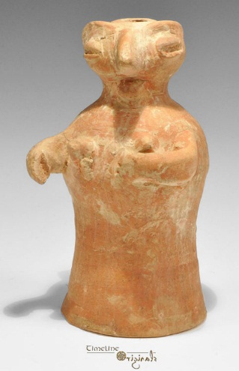

**Formal Label:**

**Accession Number:**

**Date or Time Horizon:**

**Geographical Area:**

**Cultural Affiliation:**

**Medium:**

**Dimensions:**

**Weight:**

**Provenance:**

**Condition:**

**Discussion:**

**References:**

Ceramic, 485 grams, 16 cm. 3300-1300 BCE. A terracotta tubular figurine depicting a standing female with hands clasped, the face stylized with lentoid eyes and raised brows, beaked avian nose. Fine condition, one hand lost. Provenance: ex UK art market, acquired prior to 1985.